* Gradient Descent is at the core for supervised learning in ML

## Activity

* 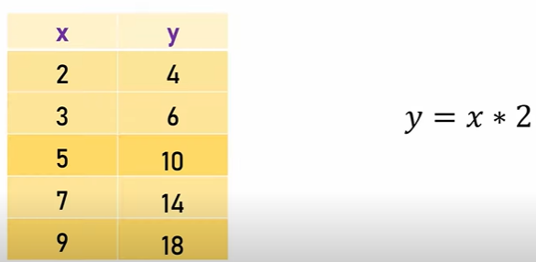
* The relationship between x and y in the above table is → y = x * 2
* 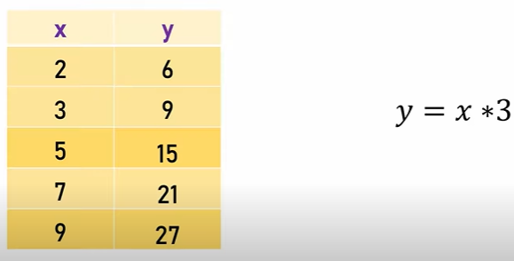
* The relationship between x and y in the above table is y = x * 3
* 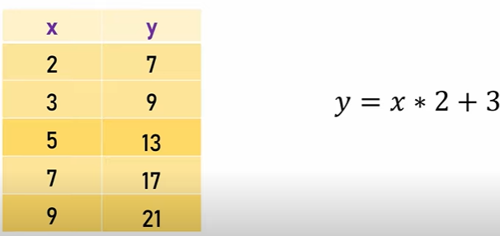
* The relationship between x and y in the above table is y = x * 2 + 3
* 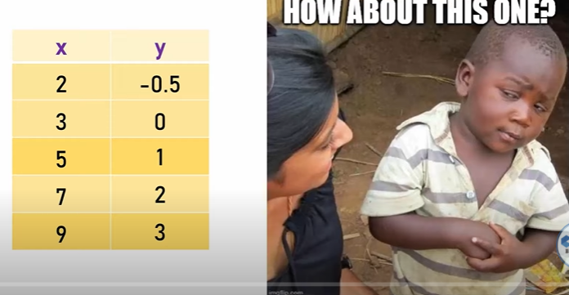
* But it is difficult to find the relationship between x and y in the above table
* Here is where gradient descent comes into picture
* Gradient descent is a technique to find the linear equation for the above table
* 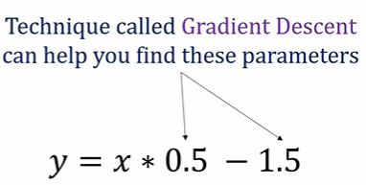
* Gradient Descent is used to get the weights and bias where the loas and cost is function is minimum
* 